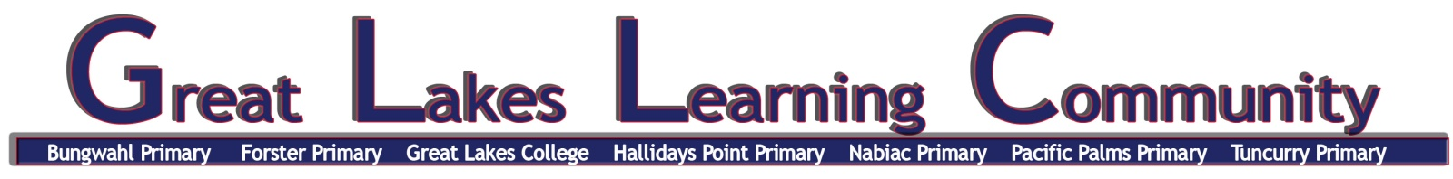

GREAT LAKES LEARNING COMMUNITY RESPECT CHARTER
Advice for Parents/Carers, Visitors and Volunteers

Staff in the Great Lakes Learning Community are committed to providing a safe learning environment that enhances the physical, educational and social/emotional development of our students for all children to be known, valued and cared for.
We also greatly value the contribution and involvement of community members who visit our schools, and we ensure that every member of our school community – students, staff, family members and volunteers feel safe and respected at all times.
Dignity and trust requires respectful behaviour from everyone in the workplace. NSW public schools are committed to providing safe, supportive and responsive learning environments for everyone. We teach and model the behaviours we value in our students.
The Great Lakes Learning Community Schools’ RESPECT CHARTER, expects that all its parents, carers, visitors and volunteers:
- treat all persons associated with the school with respect and courtesy;
- understand offensive, aggressive and threatening behaviour will not be tolerated
- sign in for a visitor's pass from the office if assisting in the school;
- make mutually convenient appointments to obtain an interview with school staff;
- allow staff to supervise, investigate and manage students without interference;
- discuss issues or concerns about the school, staff, other parents or students through the correct school procedures;
- follow school procedures governing entry and behaviour on school grounds, including any restrictions that may be imposed.

Any person contravening this Charter is advised that the provisions of the lnclosed Lands Protection Act (1901) will be enacted.

https://education.nsw.gov.au/legal/media/documents/legal-issues-bulletins/Bulletin-58-Intranet.pdf
Your co-operation is sought and greatly appreciated, so that we all maintain a safe, respectful and happy learning environment for every student, staff, parent/carer visitor and volunteer in the Great Lakes Learning Community. We look forward to a positive working relationship. Community engagement maximizes how students connect, succeed and thrive.

Principal P&C President

